|  |  |  |  |  |  |  |  |  |  |  |  |
| --- | --- | --- | --- | --- | --- | --- | --- | --- | --- | --- | --- |
| **Protocol**  Meeting Bachelor Thesis, FS 2024 | | | | | | | | | | | |
|  |  | | | | |  |  | | | | |
| **Protocol-No.:** | 04 | | | | | **Project name:** | Bachelor Thesis | | | | |
| **Meeting type:** | Discussion | | | | | **Location:** | GIUB, Bern | | | | |
| **Date / Time:** | 22.04.2024 / 15:00 | | | | |  |  | | | | |
| **Topic / Goals:** | Modelling for one Gridpoint | | | | | | | | | | |
| **Lead:** | Benjamin Stocker | | | | | **Logger:** | Patricia Gribi | | | | |
|  | | | | | | | | | | | |
| **Participants** | |  |  | | **E-mail** | | | **Present** | **Excused** | **Distribution** |
| Prof. Benjamin Stocker | |  | GECO-Group | | benjamin.stocker@unibe.ch | | | x |  |  |
| Patricia Gribi | |  | Unibe | | patricia.gribi@students.unibe.ch | | | x |  |  |
|  | | | | | | | | | | | |
| **Items discussed:** | | | | | | | | | | | |
| 1 Modelling for one Gridpoint | | | | | | | | | | | |
| **Next meeting:** | | | | **Attachments:** | | | | | | | |
| * 29.04.22/15.00 | | | | * Annual totals of one grid point of pec, et and pet | | | | | | | |

| *(Legend for type: D = Decision, P = Pending, I = Information)* | Typ | Resp.: | Date: |
| --- | --- | --- | --- |
| Proposal |  |  |  |
| * **Timeline:** The daily resolution is left and for the presentation preparation one week is planned. | I |  | 22.04 |
| Modelling |  |  |  |
| * **Gridpoint extraction:** Now it is easily understandable which gridpoint is extracted. The function extract_gridpoint was expanded, so that longitude and latitude can be given as parameters to the function. | I |  | 09.04 |
| * **Grid:** 0-360 degrees east. Start is at Greenwich Meridian. With a World Map from the terra package it becomes obvious. | I |  | 22.04 |
| * **Potential evapotranspiration calculation:** PET = EET * 1.26 (units: mm d-1). EET = Rnet * f(T), where f(T) is a temperature-dependent function that converts Rnet (in units W m-2) into mass units (mm d-1) according to Eq. 19 in Davis et al. The function is implemented by convert_et(). | I |  | 12.04 |
| * It appears that at certain grid points, PET values are higher than ET values. This discrepancy suggests a potential error in the units somewhere, which needs to be identified and corrected. Compare pet with FLUXNET values. | P |  | 29.04 |
| * **Interpolation:** Change interpolation in order that all days have the same monthly value. | P |  | 29.04 |
| * **Calc_patm:** Function for the calculation of the atmospheric pressure. As 'elv' (height above sea level) it would be ideal to use the information from the model grid. Is not available, the only thing found was the pressure at top level of the land model, corresponding to 2.25 millibars. Used 0 m for now. For a gridpoint same height, but when global then different heights. | I |  | 16.04 |
| Next Steps: Modelling cwd and pcwd globally |  |  |  |
| * Write function which takes as parameters et and prec and returns the cwd and pcwd timeseries. The function should be scalable. Inputs: evspsbl, precipitation. | P |  | 29.04 |
| Workflow |  |  |  |
| * **Move data to data scratch directory:** data/scratch/CMIP6ng/cmip6-ng. Could not do it permission denied creating new folder and without does not work because some variables have the same name. | I |  | 22.04 |

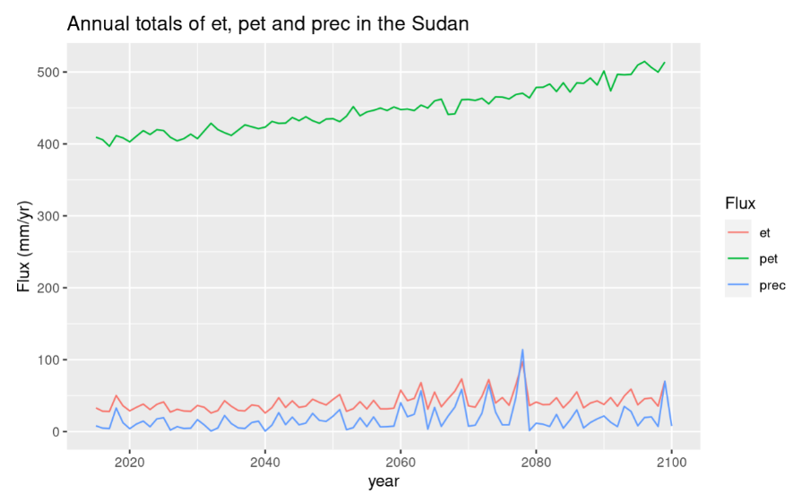**Latitude 20, Longitude 30**

In Sudan, the patterns of evapotranspiration (et) and precipitation (prec) exhibit closely aligned fluctuations, indicating a system constrained by water availability. This suggests that the runoff, the portion of precipitation that does not infiltrate the soil and contributes to streams and rivers, is likely minimal or remains relatively constant over time. Additionally, there is no significant long-term alteration observed in the storage of water resources.

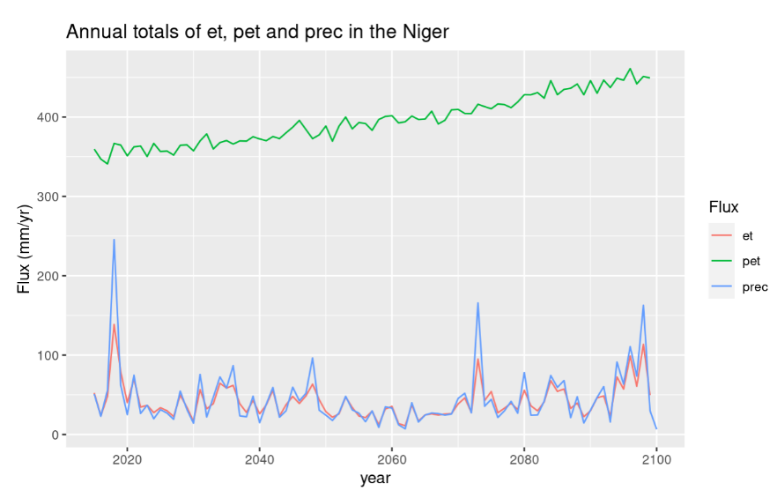

**Latitude 20, Longitude 10**

Niger, Sahara-desert

Why net radiation not negative in the desert? Shouldn’t they have an energy loss?

et close to zero because it is so dry. precipitation higher but it will instantly infiltrate in the soil and plants will need it. correct?

**Latitude -5, Longitude -62**

(Converted longitude 298)

**Potential Evapotranspiration:**

Why are there parts where evapotranspiration is higher than potential evapotranspiration?

Maybe due to interpolation of pet. Radiation was only monthly available and et daily. Can be huge difference

if for instance at the beginning of month low radiation values but in the middle of the month there would

be high values.

**Limited Solar Radiation**: Solar radiation provides the energy needed to drive the evaporation process. Reduced solar radiation, such as during cloudy or overcast conditions, can lead to lower potential evapotranspiration rates.

